Triglycerides

Triglycerides are a glycerol bonded to 3 fatty acid tails.

Mono- and diglycerides also exist, with 1 and 2 fatty acid tails respectively.

They are used in

A condensation reaction joins the glycerol and the fatty acids. This results in an ester bond forming between the carboxyl group (COOH) of the fatty acid and the hydroxyl group (OH) from the glycerol. Water is released also.

The triglyceride can be broken down in a hydrolysis reaction.

Lipase is the enzyme used to break down triglycerides.
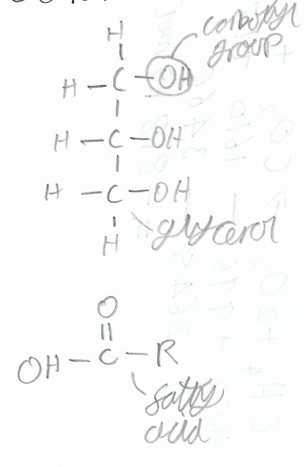
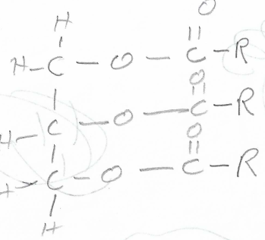

In a condensation reaction

The fatty acids in a triglyceride can be saturated or unsaturated.

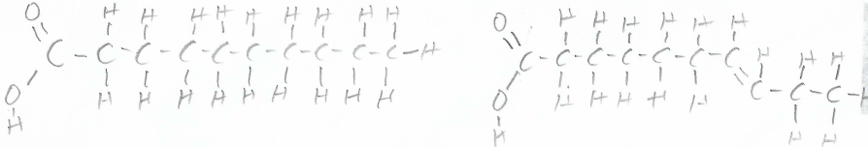
(saturated) (unsaturated)

If a lipid has unsaturated triglycerides, then the fat is generally a plant fat. These fats have kinks, so they do not pack together as effectively, making them liquid at room temperature.

Saturated fats are usually animal fats, so they have no kinks. This means they pack tightly together, making them a solid at room temperature.
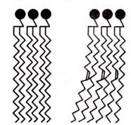
(left = saturated, right = unsaturated)

